Exercise 4
Git Version Control and GitHub Collaboration

Aim
To create a local Git repository, commit changes, create a branch and synchronize a project with GitHub.

Software Required
- Git
- GitHub account
- Git Bash/Terminal
- Any text editor or IDE

Procedure
- Create a folder named StudentProject containing index.html and README.md.
- Open a terminal in the folder.
- Configure the Git username and email.
- Initialize the repository.
- Check the repository status.
- Stage and commit the initial files.
- Create a GitHub repository with the same project name.
- Connect the local repository to the GitHub remote.
- Push the main branch.
- Create a feature branch, modify a file, commit and push it.
- Create a pull request on GitHub and merge it.
- Pull the latest changes into the local repository.

Commands
git init
git config --global user.name "Student Name"
git config --global user.email "student@example.com"
git status
git add .
git commit -m "Initial commit"
git branch -M main
git remote add origin <YOUR_GITHUB_REPOSITORY_URL>
git push -u origin main
git checkout -b feature/student-page
git add .
git commit -m "Added student page"
git push -u origin feature/student-page
git checkout main
git pull origin main
Important Concepts
Command/Concept | Purpose
git init | Creates a local repository
git status | Shows changed/staged files
git add | Stages changes
git commit | Creates a version snapshot
git branch | Creates/manages branches
git push | Uploads commits to remote repository
git pull | Downloads and integrates remote changes
Pull Request | Proposes changes for review and merge

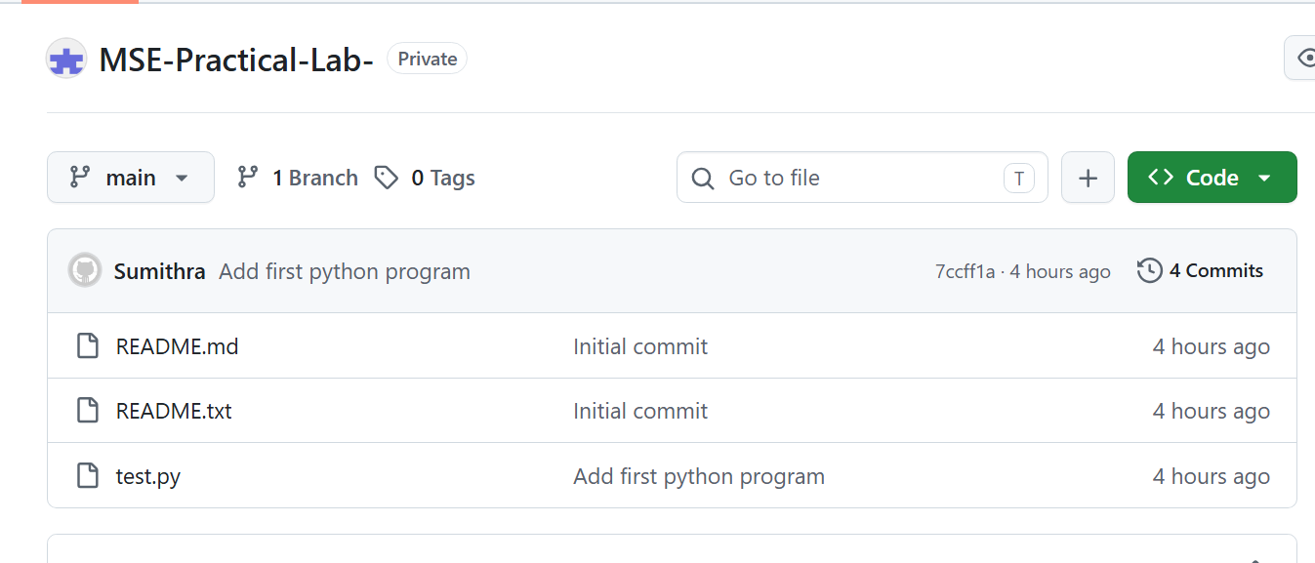

Result
Thus the experiment was successfully performed and the expected result was obtained.

